**Twitter Sentiment Analysis**

**Below analysis has done on Obama tweets data.**

**Word Cloud**

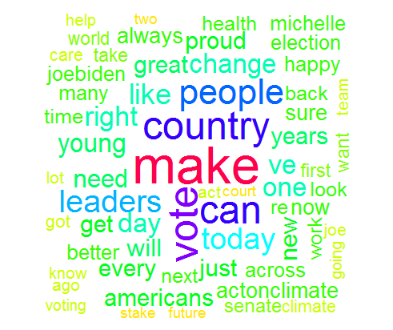

**Word Cloud Positive words**

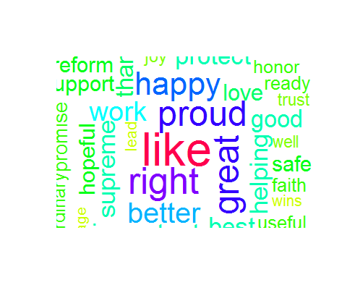

**Word Cloud Negative Words**

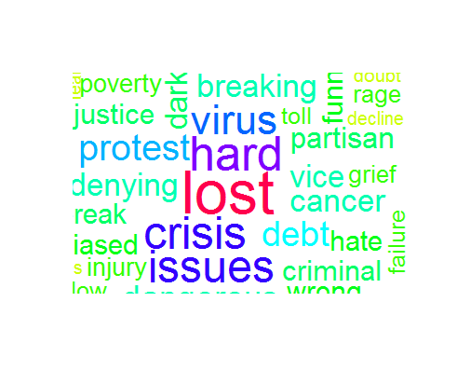

**Bar chart of emotions**

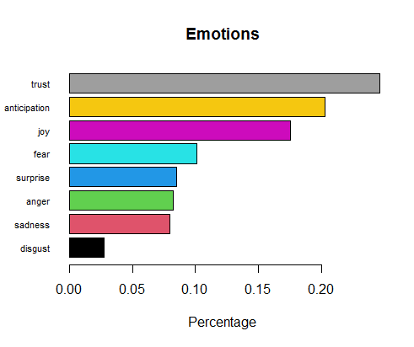

**Frequency chart of sentiments**

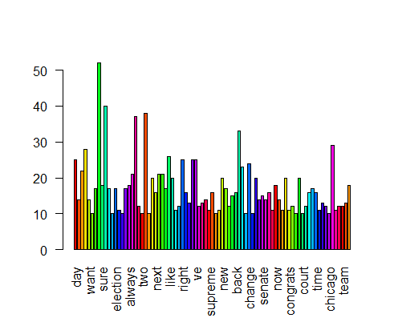

**Percentage chart**

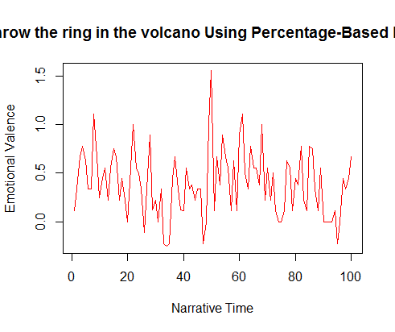

**sentiments chart**

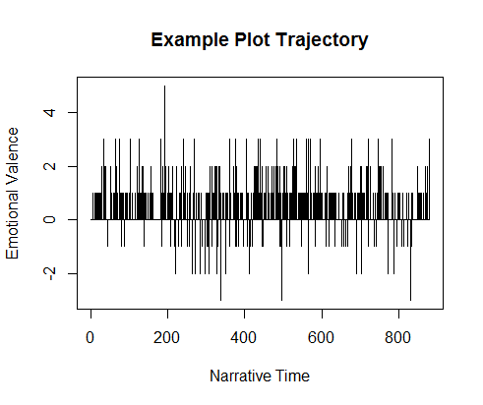

**Most positive tweet**

**I'm proud to endorse this diverse and hopeful collection of thoughtful, empathetic, and highly qualified Democrats.… https://t.co/u6X6CJK2uz"**

**Most negative tweet**

**"Through centuries of persecution, exile and struggle, the story of Passover has reminded the Jewish people––and all… https://t.co/Ks8gXDHjzR"**

**Amazon Product Review Sentiment Analysis**

**Below analysis has done on Sony Bravia 108 model product .**

**Word Cloud**

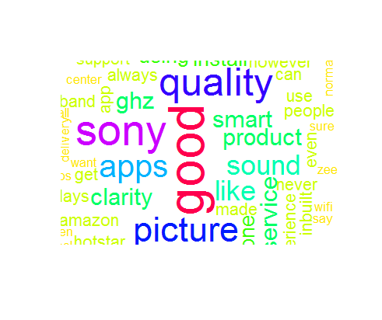

**Word Cloud Positive words**

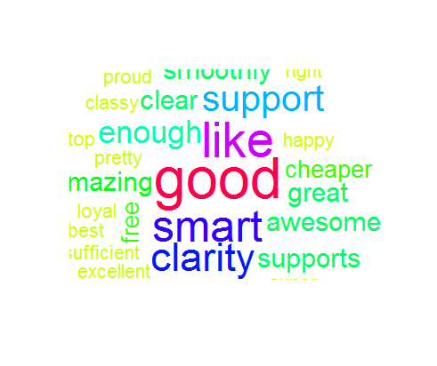

**Word Cloud Negative Words**

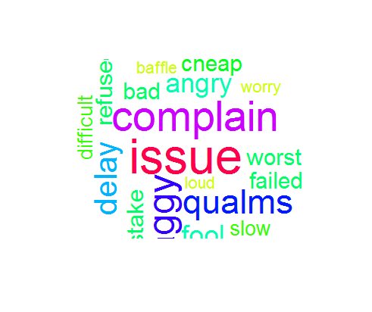

**Bar chart of emotions**

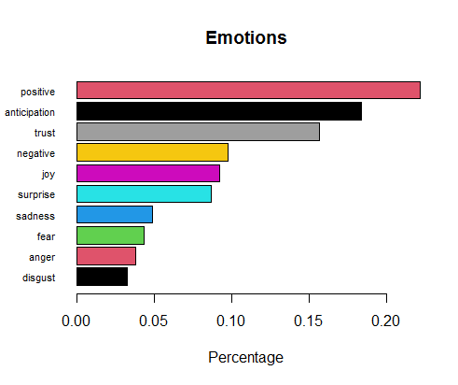

**Frequency chart of sentiments**

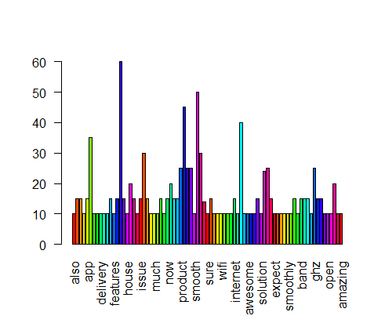

**Percentage chart**

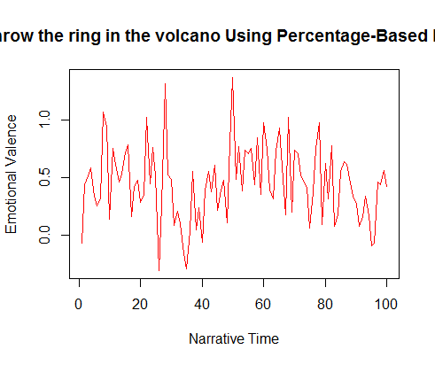

**sentiments chart**

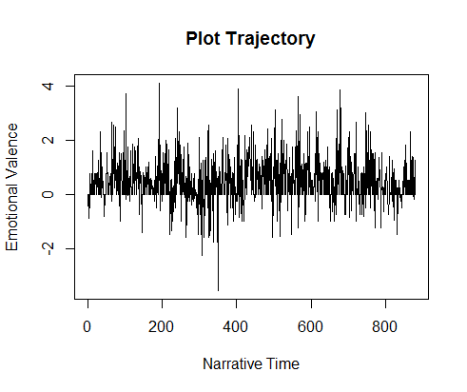

**Most positive review**

**It only supports 2.4 GHz, which MIGHT cause some buffering issues while using the inbuilt OTT apps on TV.**

**Most negative review**

**The OS is not android based but never felt it's performance is lacking in anyways.**